

**INDUSTRIAL ATTACHMENT REPORT**

**Title**: Industrial Attachment Report at the Ministry of Education, Kenya (Athi River Sub-County Director of Education Office)   
**Name**: James Mukuvi Ngandu  
**Institution**: University of Eldoret  
**Department**: Department of Mathematics and Computer Science   
**Registration Number**: COM/012/22

**Duration**: 15th May 2025 – 1st August 2025

# ****Declaration****

I, **James Mukuvi Ngandu**, hereby declare that this Industrial Attachment Report is my original work and has not been submitted, wholly or partially, to any other institution or organization for academic credit or certification purposes.

I further affirm that all the information, observations and findings contained in this report are a true reflection of the activities and experiences I undertook during my industrial attachment at the **Ministry of Education, Kenya (Athi River Sub-County Director of Education Office)**, from **15th May 2025 to 1st August 2025**.

Any material from published or unpublished works by other authors that has been used in this report has been properly acknowledged and referenced in accordance with academic and ethical guidelines.

I take full responsibility for the content of this report and understand that any form of plagiarism or academic dishonesty may lead to disciplinary action as per the rules and regulations of the **University of Eldoret**.

**Student’s Name**: __________________________  
**Signature**: __________________________  
**Date**: __________________________

# ****Dedication****

I dedicate this report to my loving family, whose unwavering support, encouragement, and belief in my abilities have been a constant source of strength throughout my academic and personal journey. To my parents, who instilled in me the values of hard work, discipline, and perseverance, I remain forever grateful.

I also dedicate this work to my lecturers and mentors at the University of Eldoret, whose guidance and commitment to nurturing young professionals have greatly shaped my academic growth. To my fellow classmates and friends, thank you for your collaboration, inspiration and motivation.

Most importantly, I dedicate this report to the Almighty God for granting me good health, wisdom, and resilience during the entire period of my industrial attachment. Without His guidance and blessings, this achievement would not have been possible.

# ****Acknowledgment****

I wish to express my profound gratitude to the Ministry of Education, Kenya, specifically the Athi River Sub-County Director of Education Office, for granting me the invaluable opportunity to undertake my industrial attachment. This experience has been instrumental in bridging the gap between my academic studies and the practical demands of the public sector ICT environment.

My sincere appreciation goes to my dedicated supervisor, Mr. Oina O. Peter the Sub-County Director of Education, whose patience, guidance, and constructive feedback were pivotal throughout my attachment period. I am equally thankful to the entire staff at the Athi River Sub-County Office, especially the ICT team and the Curriculum Support, Examinations, and Administration officers, for their warm welcome, willingness to share knowledge, and collaborative spirit that made my learning experience both productive and enjoyable.

I extend my thanks to the University of Eldoret, particularly the Department of Mathematics and Computer Science, and my academic coordinator, Dr. Francis Musembi, for providing continuous support. Finally, I am deeply grateful to my family and friends for their unwavering encouragement during this period.

# ****Abstract****

This report comprehensively documents the twelve-week industrial attachment undertaken by James Mukuvi Ngandu (Com/012/22), a Bachelor of Science in Computer Science student from the University of Eldoret, at the Ministry of Education's Athi River Sub-County Director of Education Office from May 15th to August 1st, 2025. The primary attachment was within the ICT department, with significant cross-functional involvement across administrative and operational units. Key responsibilities included supporting national education management systems (NEMIS, KNEC), performing hardware/software maintenance, facilitating examination candidate registration, managing educational data, drafting official communications, and assisting in administrative events. The report details the specific activities performed, the wide range of technical and soft skills acquired (including database management, office automation, report writing, and professional communication), and the challenges encountered, such as infrastructure limitations. It concludes by highlighting the significant practical experience gained in public sector ICT administration and offers recommendations for both the host organization and the academic institution to enhance future attachment experiences. The attachment successfully fulfilled its objective of providing real-world context to theoretical knowledge.

Table of Contents

Declaration 2

Dedication 3

Acknowledgment 4

Abstract 5

Chapter 1: INTRODUCTION 9

1.1 Introduction to Industrial Attachment Concept 9

1.2 Organization Background 9

1.3 Organization Vision, Mission & Core Values 10

1.3.1 Vision 10

1.3.2 Mission 10

1.3.3 Core Values 10

1.4 Organization Structure 10

1.5 Departments and Responsibilities 11

Chapter 2: ACTIVITIES AND EXPERIENCES 13

2.1 Activities and Experiences in different Sections 13

2.2 Key Skills Acquired and Applicability 18

2.3 Challenges and Opportunities Encountered 20

2.3.1 Challenges: 20

2.3.2 Opportunities: 20

Chapter 3: CONCLUSION AND RECOMMENDATIONS 22

3.1 Conclusion 22

3.2 Recommendations 22

3.2.1 To the Organization 22

3.2.2 To the School 22

References & Appendices 24

Appendices 25

Table of Figures

Figure 1: Athi River Education Office 10

Figure 2: Organization Structure 11

Figure 3: ICT Support 12

Figure 4: Nemis Management 13

Figure 5: KNEC Portal 13

Figure 6: Software Faults 14

Figure 7: User Support 14

Figure 8: Vetting Documents 15

Figure 9: Sample of Minutes 16

Figure 10: Issuing KNEC codes 16

Figure 11: Meeting Support 17

Figure 12: Music Festival Certificate 17

Figure 13: Data Analysis 18

Figure 14: Data on Music Festivals 18

Figure 15: Organization Structure 25

Figure 16: Nemis Interface 25

Figure 17: Data on Candidature 26

Figure 18: Issuing KNEC Codes 26

Figure 19: Data Entry 27

Figure 20: Filing Section 27

**List of Abbreviations and Acronyms**

****BETA -** Bottom-Up Economic Transformation Agenda**

****BOM -**** Board of Management

****CBC -**** Competency-Based Curriculum

****ECDE -**** Early Childhood Development Education

****ICT -**** Information and Communication Technology

****IA -**** Industrial Attachment

****KNEC -**** Kenya National Examinations Council

****KCPE -**** Kenya Certificate of Primary Education

****KCSE -**** Kenya Certificate of Secondary Education

****KPSEA -**** Kenya Primary School Education Assessment

****MoE -**** Ministry of Education, Kenya

****NEMIS -**** National Education Management Information System

****QASO -**** Quality Assurance and Standards Officer

****SCDE -**** Sub-County Director of Education

# ****Chapter 1: INTRODUCTION****

## ****1.1 Introduction to Industrial Attachment Concept****

Industrial Attachment (IA), also commonly referred to as internship or work placement, is a mandatory experiential learning component integrated into the academic curriculum of many tertiary institutions, including the University of Eldoret. Its primary purpose is to bridge the gap between theoretical knowledge acquired in the classroom and the practical demands of a professional work environment. For students pursuing technical fields like Computer Science, IA is particularly crucial. It provides an invaluable platform to apply abstract concepts (e.g, database theory, systems analysis, networking fundamentals) to tangible, real-world problems and systems. Beyond technical application, the attachment period fosters the development of essential soft skills such as professional communication, teamwork, time management, and workplace etiquette. It exposes students to industry standards, organizational cultures, and current operational technologies, thereby enhancing their employability, professional awareness, and adaptability upon graduation. This report details my IA experience within the public education sector, specifically at the Athi River Sub-County Education Office.

## ****1.2 Organization Background****

The Ministry of Education (MoE) is the principal government department of Kenya responsible for the formulation, implementation, and regulation of policies, plans, and programs pertaining to Education and Training. Established at Kenya's independence, the MoE has evolved through various structural changes to meet the nation's educational needs, including the implementation of the Competency-Based Curriculum (CBC) and the current reforms under the Bottom-Up Economic Transformation Agenda (BETA). Its mandate encompasses basic education (ECDE, Primary, Secondary), tertiary education, vocational training, and special needs education. The implementation of educational policies and programs is decentralized to the County and Sub-County levels. The Athi River Sub-County Director of Education (SCDE) Office operates under the jurisdiction of the Machakos County Director of Education. Located in Athi River town, this office serves as the administrative and oversight hub for all public and private educational institutions (ECDE centres, primary schools, secondary schools, and adult education centres) within the Athi River Sub-County. Its core functions include coordinating curriculum implementation, managing teacher affairs, overseeing examinations and assessments, ensuring quality assurance and standards, managing educational infrastructure and resources, and implementing national education initiatives like NEMIS (National Education Management Information System) at the local level.

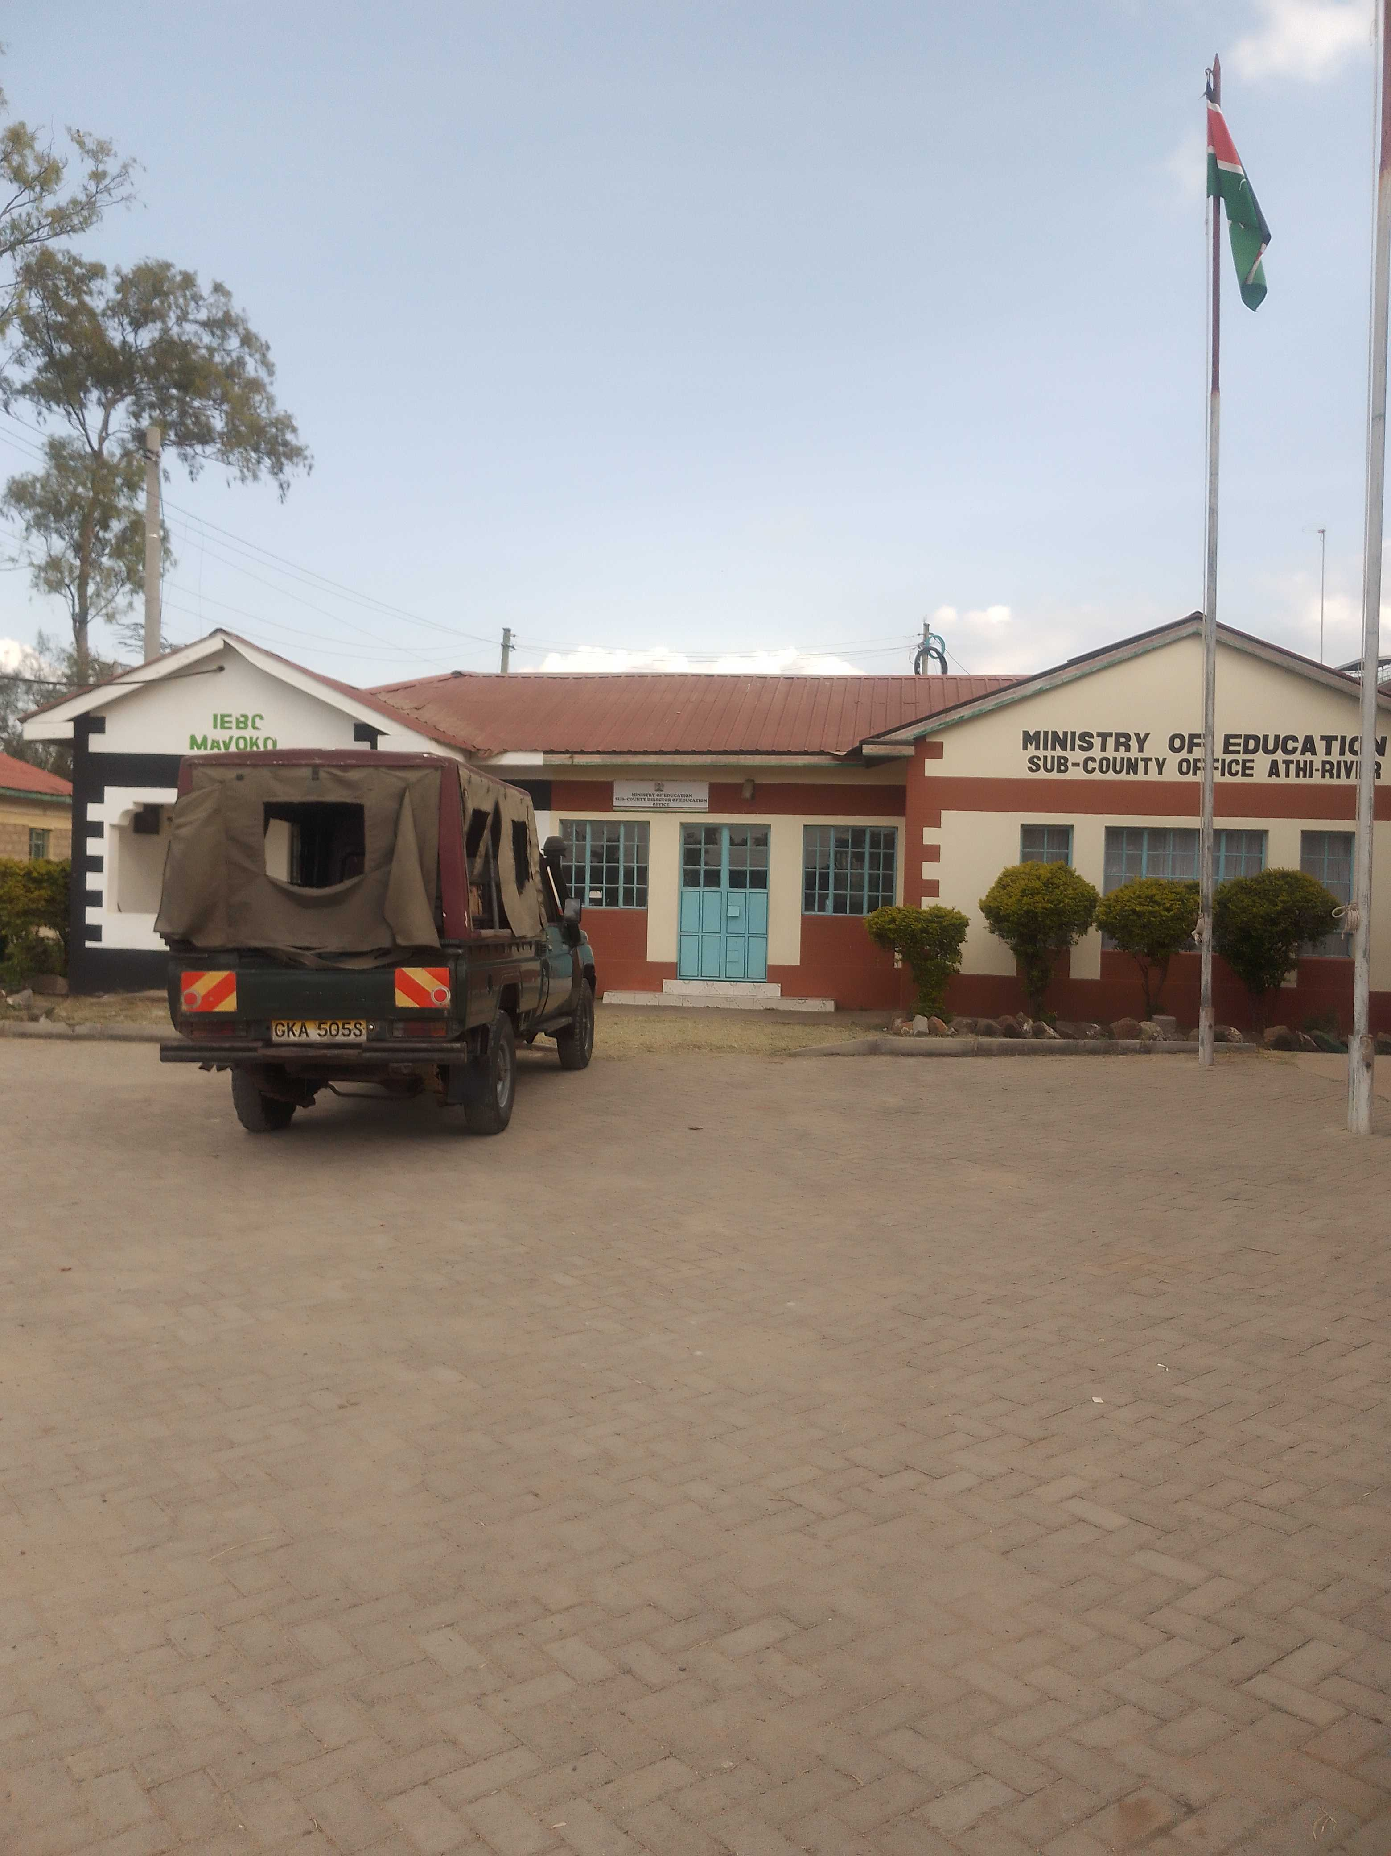Figure 1: Athi River Education Office

## ****1.3 Organization Vision, Mission & Core Values****

### ****1.3.1 Vision****

To provide quality education for sustainable development.

### 1.3.2 ****Mission****

To offer, promote and coordinate lifelong education, training and research for Kenya’s development.

### 1.3.3 ****Core Values****

Professionalism, Integrity, Equity, Teamwork, Innovation and Excellence.

## ****1.4 Organization Structure****

The Athi River Sub-County Education Office is hierarchically structured and headed by the Sub-County Director of Education (SCDE), who reports directly to the County Director of Education. The SCDE provides overall leadership and is responsible for the effective implementation of all MoE policies and programs within the Sub-County.

Supporting the SCDE are several key departments/officers, each with specialized functions:

1. **Curriculum Support Officers (CSOs):** Oversee the implementation of the curriculum, teacher professional development and learning resources in schools.
2. **Quality Assurance and Standards Officer (QASO):** Ensures schools adhere to MoE standards regarding infrastructure, teaching quality and management.
3. **Examinations and Assessment Officer:** Manages all matters related to national examinations (KPSEA, KCPE, KCSE and Adult Education) including registration, coordination and security within the Sub-County. Works closely with KNEC.
4. **ICT Officer:** Provides technical support for MoE ICT systems (primarily NEMIS, KNEC portals), manages office hardware/software and supports digital initiatives within schools.
5. **Administrative Officer/Support Staff:** Handles general office administration, finance, records management, logistics and correspondence.

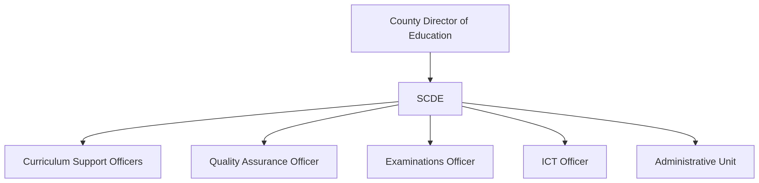Figure 2: Organization Structure

## ****1.5 Departments and Responsibilities****

My primary attachment was within the **ICT Department**, under the direct supervision of the Sub-County ICT Officer. However, the nature of the office's work necessitated significant **cross-functional involvement**, particularly with the Examinations and Assessment unit and the general administrative support team. My core responsibilities included:

1. **ICT Support:** Assisting with the management and troubleshooting of the National Education Management Information System (NEMIS), supporting KNEC online candidate registration portals, performing basic hardware maintenance (printer setup, troubleshooting), software installation/updates and virus scanning.
2. **Data Management:** Updating and verifying school data in NEMIS (e.g., learner details, school infrastructure, staffing), confirming KNEC candidate details, updating school contact databases and tracking head teacher changes.

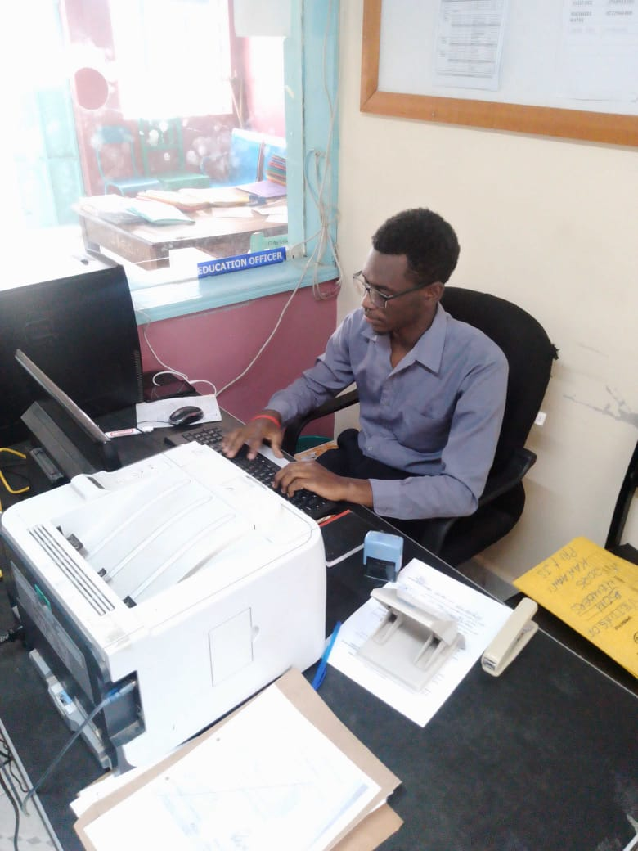Figure 3: ICT Support

1. **Examination Support:** Assisting in the registration and vetting of candidates for KPSEA, KCSE and Adult Education examinations; preparing related documentation.
2. **Administrative Support:** Drafting official letters (objections, approvals, memos), typing and distributing meeting minutes, creating Board of Management (BOM) nomination files, preparing student transfer forms, scanning, printing, and organizing government correspondence.
3. **Event Support:** Providing logistical and administrative assistance during head teacher/principal meetings, educational workshops, and the Sub-County drama festival.
4. **Reporting:** Compiling and writing basic analytical reports based on school data (e.g., infrastructure status, teacher shortages).

# ****Chapter 2: ACTIVITIES AND EXPERIENCES****

## ****2.1 Activities and Experiences in different Sections****

Throughout the 12 weeks, I engaged in various sections:

**ICT Section:**

1. **NEMIS Management:** Actively participated in updating and verifying critical school data on the NEMIS platform. This involved tasks like correcting learner registration details (names, birth certificates, parent contacts). I learned the structure of the NEMIS database and the importance of data accuracy for national planning and resource allocation.

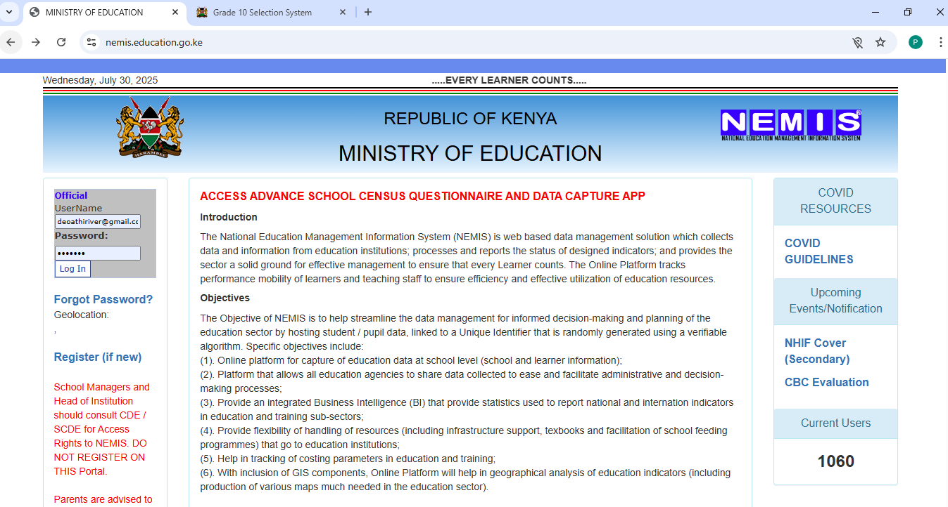Figure 4: Nemis Management

1. **KNEC Portal Support:** Assisted schools during the critical KCSE and KPSEA registration windows. Duties included guiding school ICT through the online registration process on the KNEC portal, verifying candidate bio data and subject selection entries uploaded by schools, identifying and correcting errors (e.g., mismatched index numbers, missing photos).

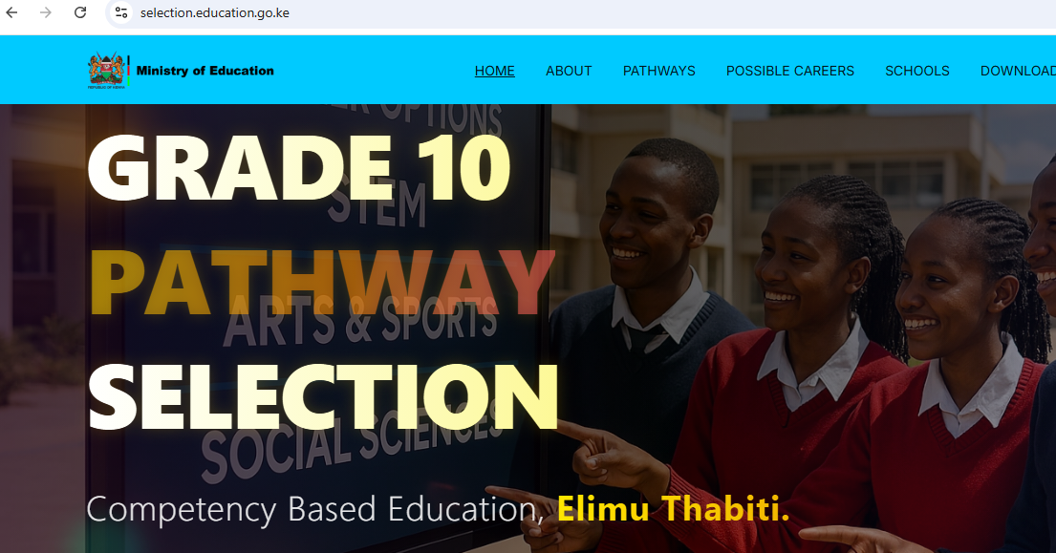Figure 5: KNEC Portal

1. **Hardware/Software Maintenance:** Performed routine maintenance on office computers and printers. This included installing operating system updates, deploying approved software (MS Office, antivirus), troubleshooting common hardware issues (paper jams, connectivity problems), performing virus scans and malware removal using tools like Windows Defender and setting up new peripherals. I gained practical experience in diagnosing basic hardware faults and ensuring system security.

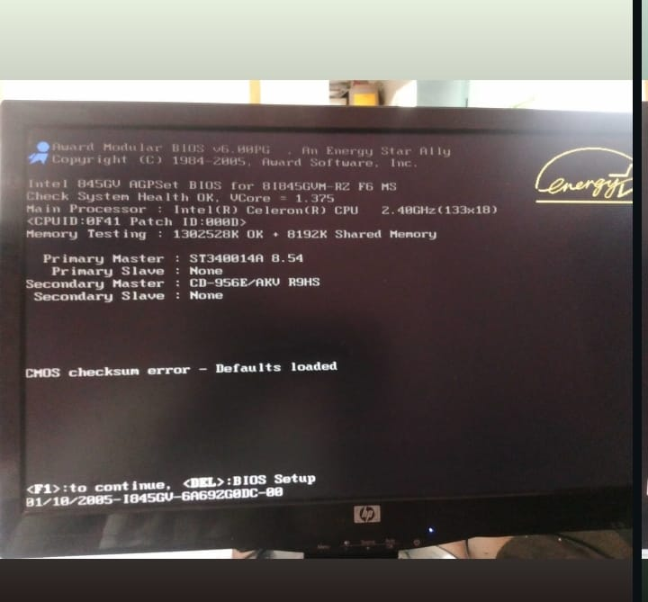Figure 6: Software Faults

1. **User Support:** Provided first-line technical support to office staff, resolving issues related to password resets, email access, printer configuration, MS Office functionality and basic internet connectivity problems. This honed my ability to communicate technical solutions clearly too non-technical users.

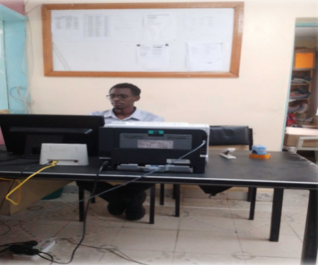Figure 7: User Support

**Examinations & Assessment Section:**

1. **Candidate Registration & Vetting:** Supported the physical vetting process for examination candidates. Assisted in compiling and organizing vetting documents for submission to the County office.

Figure 8: Vetting Documents

1. **Document Preparation:** Prepared various examination-related documents under the guidance of the Exams Officer, including cover letters for registration materials, lists of examination centres and memos to school principals regarding deadlines and requirements.

Figure 9: Sample of Minutes

**Administrative Section:**

1. **Document Drafting & Processing:** Drafted a variety of official correspondence based on templates and instructions. This included letters issuing KNEC codes to schools, approval letters for minor school projects, internal memos and Board of Management (BOM) nomination letters. Learned the formal language and protocols of government communication.
2. **Records Management:** Scanned, filed and retrieved physical documents. Prepared student transfer forms by accurately filling in learner details and obtaining necessary signatures. Ensured proper filing and tracking of outgoing and incoming correspondence.

Figure 10: Issuing KNEC codes

1. **Meeting Support:** Attended and took minutes during head teacher/principal meetings and internal staff briefings. Learned to capture key decisions, action points and responsibilities accurately. Formatted and distributed finalized minutes.

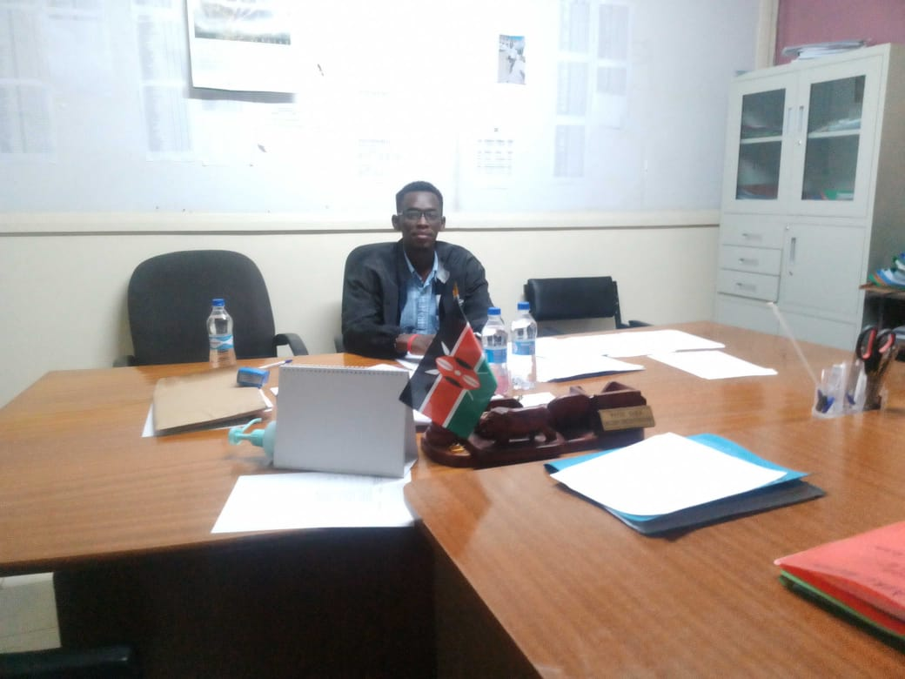Figure 11: Meeting Support

1. **Event Logistics:** Provided support during the Sub-County drama festival and head teacher workshops, assisting with registration of participants, arranging venues, managing materials distribution and basic coordination tasks.

Figure 12: Music Festival Certificate

**General Cross-Functional:**

1. **Data Analysis & Reporting:** Utilized MS Excel extensively to compile and analyze data extracted from NEMIS or collected manually. Created reports summarizing findings on specific topics, such as the status of ICT infrastructure in primary schools or teacher distribution across the Sub-County. Presented data using tables and simple charts.

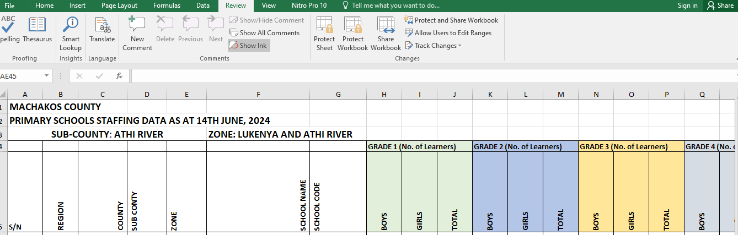Figure 13: Data Analysis

1. **Database Updates:** Maintained a local MS Excel database containing contact information (phone, email) for all head teachers and principals within the Sub-County, ensuring it was updated promptly with changes.

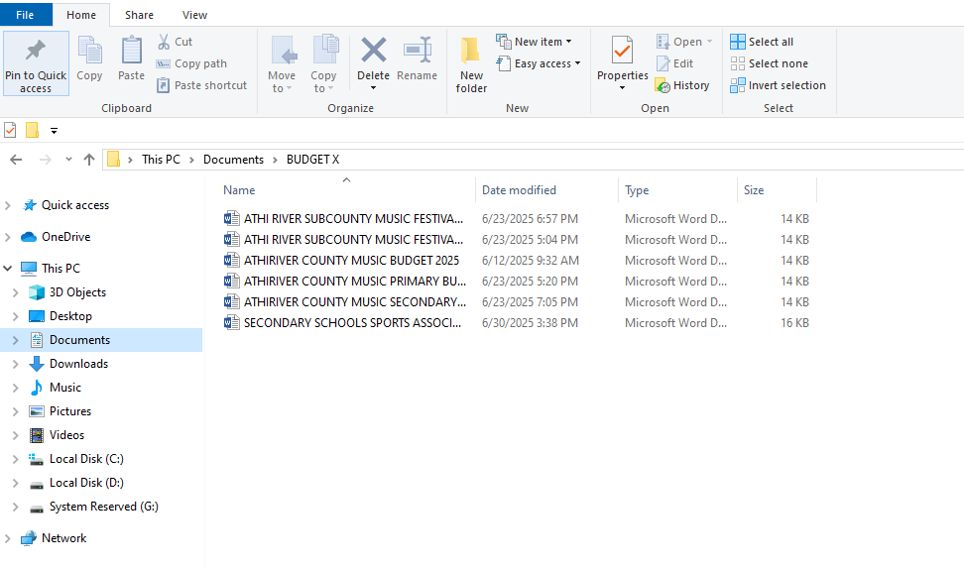Figure 14: Data on Music Festivals

## ****2.2 Key Skills Acquired and Applicability****

**Technical Skills:**

1. **Database Management (NEMIS/KNEC):** Gained practical proficiency in navigating, querying, updating and validating data within large-scale, mission-critical government database systems (NEMIS, KNEC portals).

Applicability: Directly applies to academic database courses (e.g., Database Management Systems), providing real-world context to SQL concepts and data integrity principles. Essential for roles in data administration, system support, or any position requiring interaction with complex databases.

1. **Office Automation Mastery:** Significantly enhanced practical skills in MS Word (professional document drafting, formatting reports/letters), MS Excel (data entry, sorting, filtering, formula use - SUMIF, basic charts for reporting) and MS PowerPoint (creating presentations for meetings).

Applicability: Fundamental for academic report writing, project documentation and data analysis tasks. Universally required in virtually any professional office environment.

1. **Hardware Troubleshooting & Maintenance:** Developed competence in diagnosing common PC hardware (printer jams, connectivity issues) and software problems (OS errors, application crashes and malware), performing basic repairs and preventative maintenance (updates, scans).

Applicability: Builds upon computer hardware and operating systems courses. Crucial for IT support roles, system administration and personal technical proficiency.

1. **Information System Navigation & Support:** Learned the intricacies of specific government education portals beyond just data entry, including understanding workflows, common error messages and user support procedures.

Applicability: Enhances system analysis skills learned theoretically. Prepares for supporting or managing specialized software systems in any sector.

**Administrative & Soft Skills:**

1. **Professional Report Writing:** Acquired the ability to draft clear, concise and formal documents including minutes, official letters (objections, approvals, memos) and basic analytical reports based on data.

Applicability: Vital for academic assignments requiring formal writing and documentation. Critical for communication in professional settings, project management and policy roles.

1. **Data Validation & Correction:** Developed a keen eye for detail and systematic approaches to identifying inconsistencies and errors in large datasets (learner records, candidate info) and implementing corrections.

Applicability: Applicable to data analysis courses and any role involving data quality control, research or auditing.

1. **Professional Communication:** Improved written communication through drafting formal emails and letters. Enhanced verbal communication through interactions with officers, head teachers and explaining technical issues to users.

Applicability: Essential for effective collaboration in academic group projects and paramount for success in any professional career, particularly client-facing or team-based roles.

1. **Events Coordination Support:** Gained practical experience in the logistical aspects of organizing professional meetings and events (registration, venue setup, materials management).

Applicability: Develops organizational and project coordination skills valuable for managing academic events or professional conferences.

1. **Collaboration & Teamwork:** Worked effectively within the ICT unit and collaborated seamlessly with officers from Examinations, Curriculum Support and Administration on shared tasks and projects.

Applicability: Reinforces the importance of teamwork emphasized in academic projects and is fundamental for success in any modern workplace.

1. **Time Management & Prioritization:** Learned to manage multiple tasks simultaneously (e.g., supporting registration while handling user queries and drafting a report), prioritizing urgent requests and meeting deadlines in a dynamic office environment.

Applicability: Crucial skill for balancing academic workload and meeting assignment deadlines. Indispensable for professional efficiency and productivity.

## ****2.3 Challenges and Opportunities Encountered****

### ****2.3.1 Challenges:****

1. **Infrastructure Limitations:** The most frequent challenge was **slow and unreliable internet connectivity**, especially during peak usage times or when accessing national systems like NEMIS and KNEC portals. This significantly impacted workflow efficiency, causing delays in data entry, report generation and candidate registration support. Resolution/Adaptation: Learned to schedule bandwidth-intensive tasks for off-peak hours (early morning/late afternoon), utilize cached data where possible and develop patience and persistence. Explored basic offline data preparation in Excel for later bulk upload.
2. **Access to Modern Tools:** Limited availability of up-to-date hardware (older computers) and specialized software sometimes restricted the efficiency or scope of tasks (e.g., data analysis could have been more sophisticated with advanced tools). Resolution/Adaptation: Maximized the use of available tools (especially MS Excel), sought guidance from the ICT officer on workarounds and focused on core functionalities achievable with existing resources. Appreciated the resourcefulness needed in public sector environments.
3. **Navigating Bureaucracy:** Understanding the formal protocols, hierarchies and approval processes for certain tasks required time and observation. Resolution/Adaptation: Closely observed supervisors, asked clarifying questions when unsure and strictly adhered to provided templates and instructions for official communications.

### ****2.3.2 Opportunities:****

1. **Real-World System Exposure:** Gained invaluable, hands-on experience with Kenya's core education management systems (NEMIS, KNEC portals) that are central to the sector's administration. This practical knowledge is rarely accessible in an academic setting.
2. **Insight into Public Administration:** Observed firsthand the complexities, challenges and processes involved in managing public education at the grassroots level, including policy implementation, resource constraints and stakeholder coordination.
3. **Professional Networking:** Had the privilege to interact directly and work alongside experienced Education Officers, ICT professionals within the ministry and school administrators (Head teachers/Principals), expanding my professional network and understanding of career paths.
4. **Understanding ICT's Role in Education:** Deepened my appreciation for the critical role ICT plays not just in back-office administration, but in supporting teaching, learning, assessment, and educational planning at a systemic level.
5. **Developing Adaptability:** Operating within the constraints (internet, power, resources) significantly improved my ability to adapt, problem-solve creatively and find workable solutions – a crucial skill in any work environment.

# ****Chapter 3: CONCLUSION AND RECOMMENDATIONS****

## ****3.1 Conclusion****

The twelve-week industrial attachment at the Athi River Sub-County Director of Education Office proved to be an immensely valuable and trans-formative experience, successfully fulfilling the core objectives of bridging academic theory with practical application. Immersed in the operational heart of public education administration, I gained profound, hands-on experience with critical national systems like NEMIS and KNEC portals, moving beyond theoretical database concepts to real-world data management, validation, and reporting. My technical skills were significantly enhanced through practical hardware/software troubleshooting, office automation mastery and navigating complex government ICT platforms. Equally important was the development of crucial soft skills: professional communication through drafting formal documents, collaboration within and across teams, meticulous attention to detail in data handling and improved time management in a dynamic environment.

Exposure to the inner workings of the Ministry of Education provided deep insights into the challenges and complexities of public sector administration, particularly regarding resource constraints and infrastructure limitations. Despite these challenges, the experience highlighted the critical importance of ICT in driving efficiency and accountability in educational management. The attachment solidified my understanding of the practical applications of my Computer Science degree within a vital national sector and provided clarity on potential career paths at the intersection of technology and public service. Overall, the attachment was instrumental in developing my professional competence, confidence and readiness for the workforce, providing a realistic and enriching complement to my academic studies at the University of Eldoret.

## ****3.2 Recommendations****

### ****3.2.1 To the Organization****

1. Invest in upgrading both hardware and software infrastructure, including modern desktop computers, printers and updated operating systems.
2. Establish a stable and high-speed internet connection to improve access to national platforms like NEMIS, KNEC and KEMIS.
3. Initiate a structured mentorship and on boarding program for ICT attachment students, assigning them to diverse tasks under supervision.
4. Consider organizing short training sessions or workshops for attachment students to further bridge the gap between theory and practice.

### ****3.2.2 To the School****

1. Integrate practical modules into the ICT curriculum focusing on real-world platforms such as NEMIS, KNEC portals and other government information systems.
2. Provide students with opportunities to conduct data entry and verification as part of coursework.
3. Expose students to basic networking, system administration and digital record keeping through labs and simulation environments.
4. Encourage project-based learning that incorporates administrative data handling and reporting.
5. Support students in undertaking research-based assignments on ICT in public service.

# ****References & Appendices****

1. County Government of Machakos, Department of Education. (2023). Annual education sector review report: Athi River Sub-County. Machakos, Kenya: Author.

Kenya National Examinations Council. (2023). Examination guidelines and procedures manual. Nairobi, Kenya: Author.

Ministry of Education, Kenya. (2022). Education sector policy on ICT integration in teaching and learning. Nairobi, Kenya: MoE Publications.

National Education Management Information System. (2024). User manual for school administrators. Retrieved from https://nemis.education.go.ke

Quality Assurance and Standards Directorate. (2020). School supervision handbook. Nairobi, Kenya: Ministry of Education.

Republic of Kenya. (2013). The Basic Education Act, 2013 (No. 14 of 2013). Kenya Gazette Supplement, *115* (52). Nairobi: Government Printer.

Teachers Service Commission. (2021). Teacher performance appraisal and development (TPAD) guidelines. Nairobi, Kenya: Author.

## ****Appendices****

1. **Appendix A:** Organizational Chart of Athi River Sub-County Education Office (Simplified Structure)

Figure 15: Organization Structure

1. **Appendix B:** Screenshot: NEMIS Interface

Figure 16: Nemis Interface

1. **Appendix C: candidature**

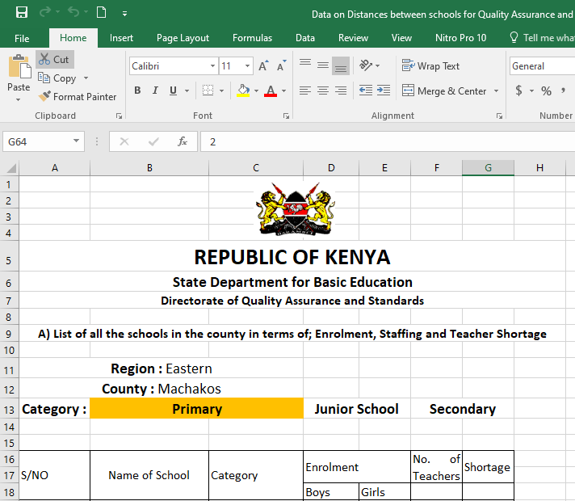Figure 17: Data on Candidature

1. **Appendix D: Issuing a Knec code**

Figure 18: Issuing KNEC Codes

1. **Appendix E: Data Entry**

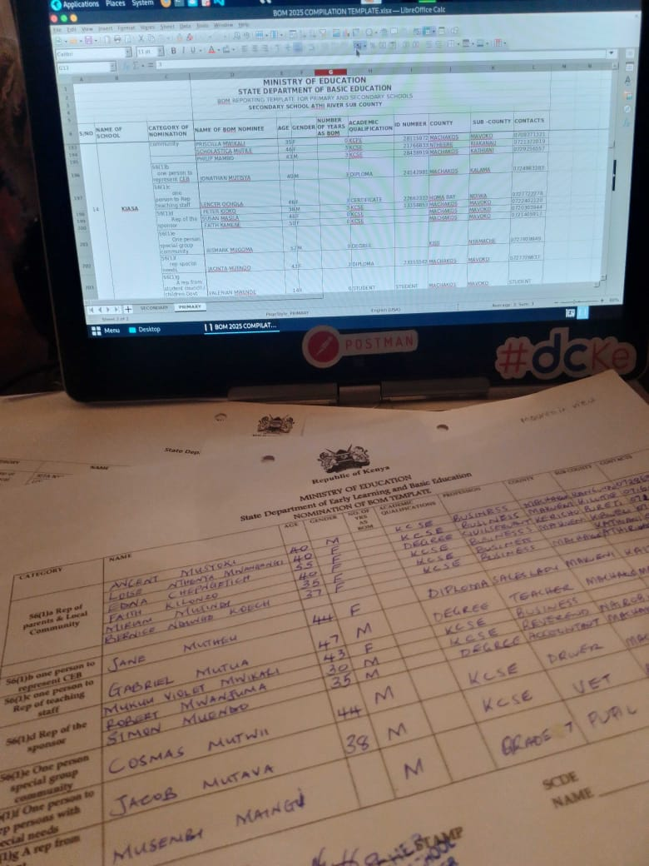Figure 19: Data Entry

1. **Appendix F: **Filing****

Figure 20: Filing Section